Cu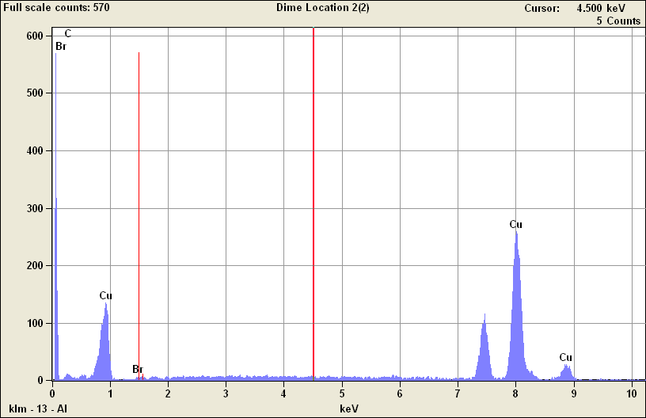

Quantitative Results for: Dime Location 2(2)
Element  Line | K-Ratio | Weight % | Weight %  Error | Atom % | Atom %  Error | Formula | Norm.  Compnd%
C K | 0.04 | 16.74 | +/- 3.11 | 51.58 | +/- 9.58 | C | 16.74
Cu K | 0.96 | 82.60 | +/- 2.43 | 48.11 | +/- 1.42 | Cu | 82.60
Cu L | --- | --- | --- | --- | --- |  | ---
Br K | 0.01 | 0.66 | +/- 1.33 | 0.31 | +/- 0.62 | Br | 0.66
Br L | --- | --- | --- | --- | --- |  | ---
Br M | --- | --- | --- | --- | --- |  | ---
Total |  | 100.00 |  | 100.00 |  |  | 100.00

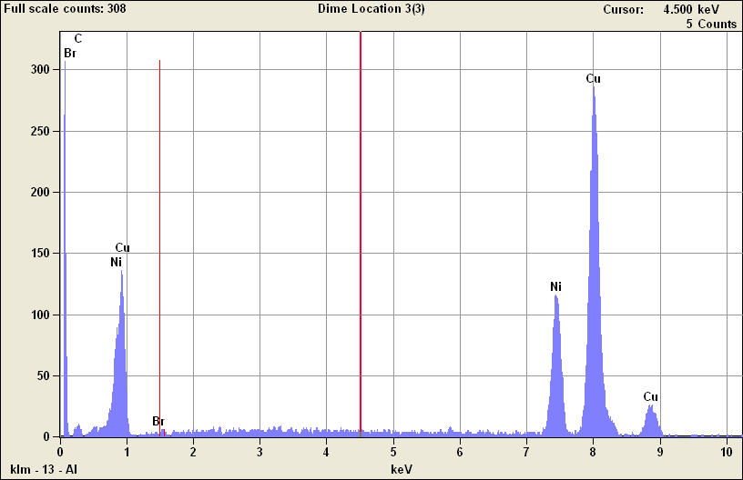

Quantitative Results for: Dime Location 3(3)
Element  Line | K-Ratio | Weight % | Weight %  Error | Atom % | Atom %  Error | Formula | Norm.  Compnd%
C K | 0.02 | 8.85 | +/- 1.99 | 33.51 | +/- 7.52 | C | 8.85
Ni K | 0.25 | 22.16 | +/- 0.73 | 17.17 | +/- 0.57 | Ni | 22.16
Ni L | --- | --- | --- | --- | --- |  | ---
Cu K | 0.73 | 68.49 | +/- 1.82 | 49.04 | +/- 1.30 | Cu | 68.50
Cu L | --- | --- | --- | --- | --- |  | ---
Br K | 0.00 | 0.50 | +/- 0.75 | 0.29 | +/- 0.43 | Br | 0.50
Br L | --- | --- | --- | --- | --- |  | ---
Br M | --- | --- | --- | --- | --- |  | ---
Total |  | 100.00 |  | 100.00 |  |  | 100.00

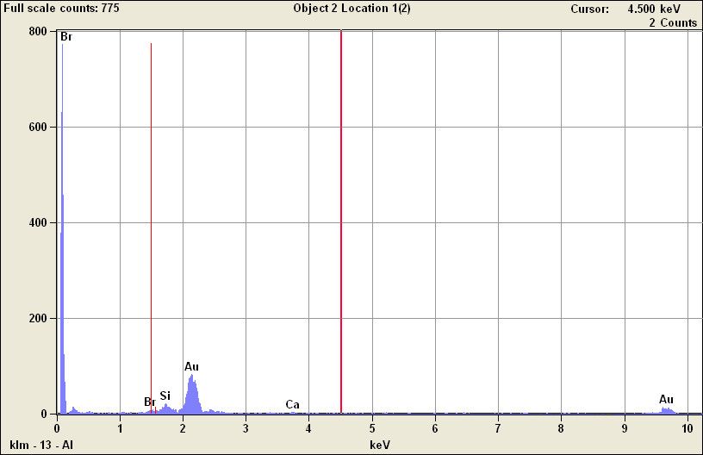

Quantitative Results for: Object 2 Location 1(2)
Element  Line | K-Ratio | Weight % | Weight %  Error | Atom % | Atom %  Error | Formula | Norm.  Compnd%
Si K | 0.04 | 4.51 | +/- 0.62 | 22.98 | +/- 3.15 | Si | 4.51
Ca K | 0.01 | 1.47 | +/- 0.65 | 5.23 | +/- 2.33 | Ca | 1.46
Ca L | --- | --- | --- | --- | --- |  | ---
Br K | 0.04 | 3.25 | +/- 5.06 | 5.83 | +/- 9.06 | Br | 3.25
Br L | --- | --- | --- | --- | --- |  | ---
Br M | --- | --- | --- | --- | --- |  | ---
Au L | 0.91 | 90.77 | +/-16.55 | 65.96 | +/-12.03 | Au | 90.77
Au M | --- | --- | --- | --- | --- |  | ---
Total |  | 100.00 |  | 100.00 |  |  | 100.00

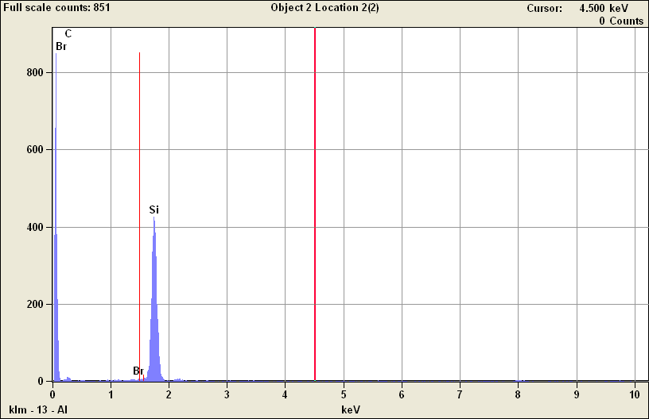

Quantitative Results for: Object 2 Location 2(2)
Element  Line | K-Ratio | Weight % | Weight %  Error | Atom % | Atom %  Error | Formula | Norm.  Compnd%
C K | 0.14 | 54.94 | +/- 8.28 | 74.03 | +/-11.16 | C | 54.94
Si K | 0.86 | 45.06 | +/- 0.73 | 25.97 | +/- 0.42 | Si | 45.06
Br K | --- | 0.00 | --- | 0.00 | +/- 0.00 | Br | ---
Br L | --- | --- | --- | --- | --- |  | ---
Br M | --- | --- | --- | --- | --- |  | ---
Total |  | 100.00 |  | 100.00 |  |  | 100.00

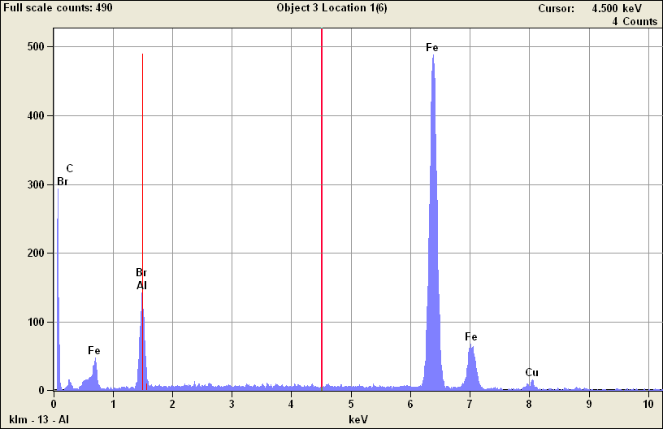

Quantitative Results for: Object 3 Location 1(6)
Element  Line | K-Ratio | Weight % | Weight %  Error | Atom % | Atom %  Error | Formula | Norm.  Compnd%
C K | 0.03 | 11.71 | +/- 1.95 | 35.84 | +/- 5.97 | C | 11.71
Al K | 0.05 | 8.89 | +/- 0.22 | 12.11 | +/- 0.29 | Al | 8.89
Fe K | 0.89 | 76.58 | +/- 1.04 | 50.41 | +/- 0.69 | Fe | 76.58
Fe L | --- | --- | --- | --- | --- |  | ---
Cu K | 0.03 | 2.82 | +/- 0.39 | 1.63 | +/- 0.23 | Cu | 2.82
Cu L | --- | --- | --- | --- | --- |  | ---
Br K | --- | 0.00 | --- | 0.00 | +/- 0.00 | Br | ---
Br L | --- | --- | --- | --- | --- |  | ---
Br M | --- | --- | --- | --- | --- |  | ---
Total |  | 100.00 |  | 100.00 |  |  | 100.00

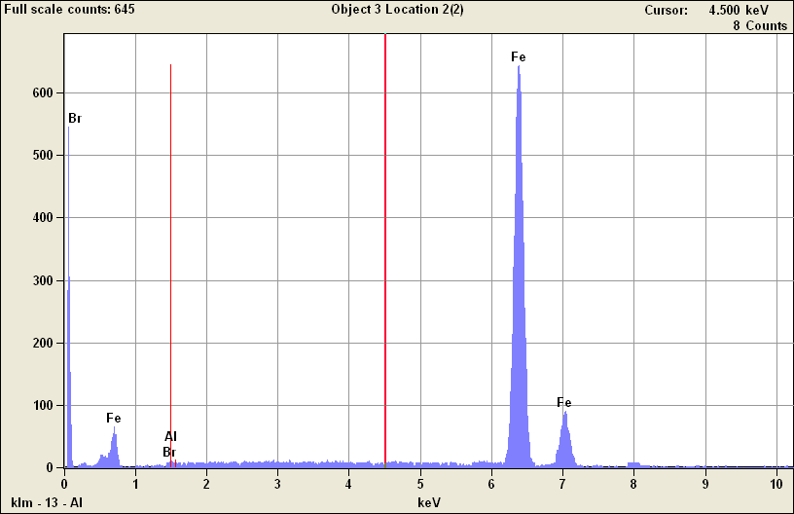

Quantitative Results for: Object 3 Location 2(2)
Element  Line | K-Ratio | Weight % | Weight %  Error | Atom % | Atom %  Error | Formula | Norm.  Compnd%
Al K | 0.00 | 0.08 | +/- 0.16 | 0.16 | +/- 0.33 | Al | 0.08
Fe K | 1.00 | 99.55 | +/- 1.42 | 99.58 | +/- 1.42 | Fe | 99.55
Fe L | --- | --- | --- | --- | --- |  | ---
Br K | 0.00 | 0.37 | +/- 1.01 | 0.26 | +/- 0.70 | Br | 0.37
Br L | --- | --- | --- | --- | --- |  | ---
Br M | --- | --- | --- | --- | --- |  | ---
Rh K | --- | --- | --- | --- | --- |  | ---
Rh L | --- | 0.00 | --- | 0.00 | +/- 0.00 | Rh | ---
Rh M | --- | --- | --- | --- | --- |  | ---
Total |  | 100.00 |  | 100.00 |  |  | 100.00

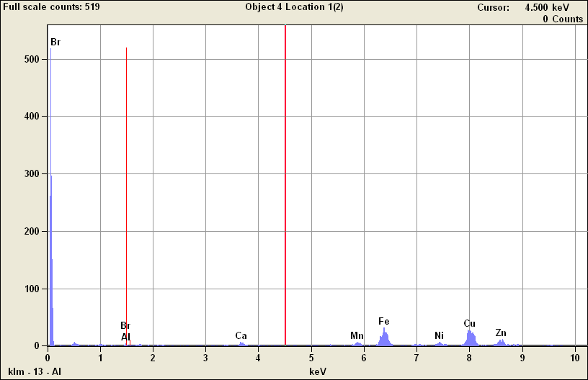

Quantitative Results for: Object 4 Location 1(2)
Element  Line | K-Ratio | Weight % | Weight %  Error | Atom % | Atom %  Error | Formula | Norm.  Compnd%
Al K | 0.00 | 1.38 | +/- 0.31 | 3.03 | +/- 0.67 | Al | 1.38
Ca K | 0.03 | 2.46 | +/- 0.33 | 3.65 | +/- 0.49 | Ca | 2.46
Ca L | --- | --- | --- | --- | --- |  | ---
Mn K | 0.04 | 4.23 | +/- 0.70 | 4.57 | +/- 0.75 | Mn | 4.23
Mn L | --- | --- | --- | --- | --- |  | ---
Fe K | 0.27 | 23.84 | +/- 1.41 | 25.36 | +/- 1.50 | Fe | 23.84
Fe L | --- | --- | --- | --- | --- |  | ---
Ni K | 0.05 | 5.23 | +/- 1.10 | 5.29 | +/- 1.11 | Ni | 5.23
Ni L | --- | --- | --- | --- | --- |  | ---
Cu K | 0.38 | 40.29 | +/- 2.67 | 37.67 | +/- 2.49 | Cu | 40.29
Cu L | --- | --- | --- | --- | --- |  | ---
Zn K | 0.21 | 22.12 | +/- 3.82 | 20.10 | +/- 3.47 | Zn | 22.12
Zn L | --- | --- | --- | --- | --- |  | ---
Br K | 0.00 | 0.45 | +/- 3.16 | 0.34 | +/- 2.35 | Br | 0.45
Br L | --- | --- | --- | --- | --- |  | ---
Br M | --- | --- | --- | --- | --- |  | ---
Total |  | 100.00 |  | 100.00 |  |  | 100.00

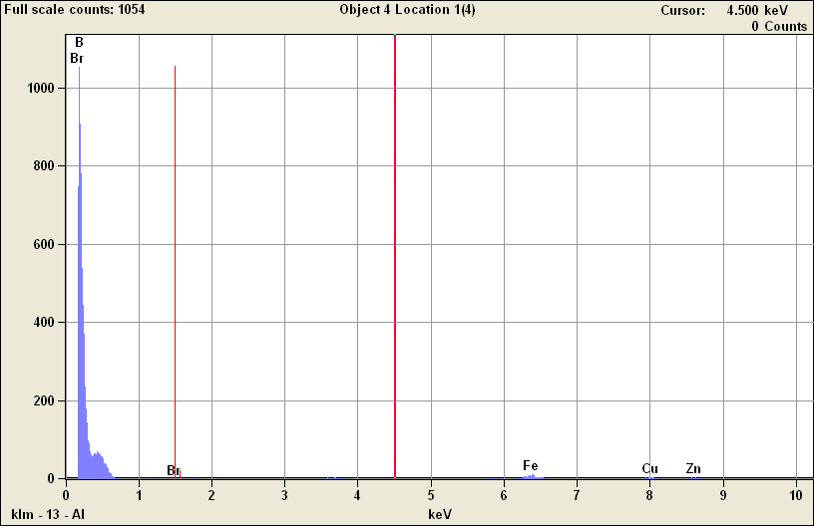

Quantitative Results for: Object 4 Location 1(4)
Element  Line | K-Ratio | Weight % | Weight %  Error | Atom % | Atom %  Error | Formula | Norm.  Compnd%
B K | 0.99 | 98.88 | +/- 3.65 | 99.80 | +/- 3.69 | B | 98.88
Fe K | 0.01 | 0.57 | +/- 0.11 | 0.11 | +/- 0.02 | Fe | 0.57
Fe L | 0.00 | --- | --- | --- | --- |  | ---
Cu K | 0.00 | 0.25 | +/- 0.08 | 0.04 | +/- 0.01 | Cu | 0.25
Cu L | 0.00 | --- | --- | --- | --- |  | ---
Zn K | 0.00 | 0.30 | +/- 0.09 | 0.05 | +/- 0.02 | Zn | 0.30
Zn L | 0.00 | --- | --- | --- | --- |  | ---
Br K | 0.00 | 0.00 | --- | 0.00 | +/- 0.00 | Br | 0.00
Br L | 0.00 | --- | --- | --- | --- |  | ---
Br M | 0.00 | --- | --- | --- | --- |  | ---
Total |  | 100.00 |  | 100.00 |  |  | 100.00

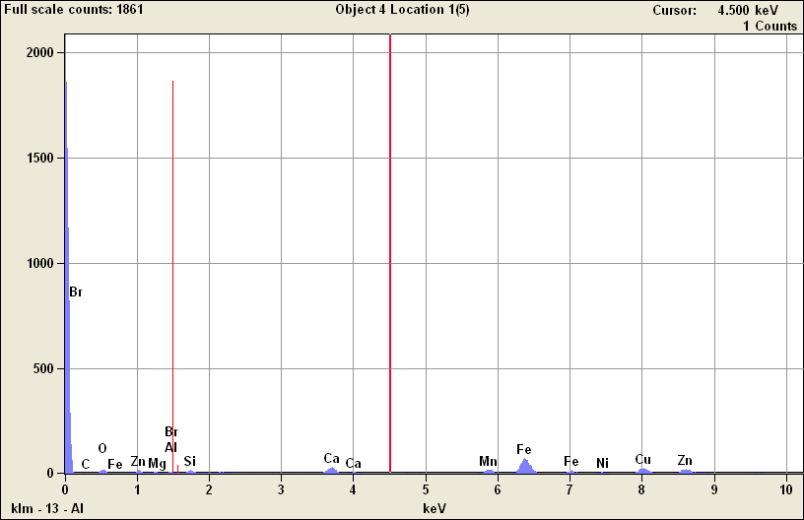

Quantitative Results for: Object 4 Location 1(5)
Element  Line | K-Ratio | Weight % | Weight %  Error | Atom % | Atom %  Error | Formula | Norm.  Compnd%
C K | 0.02 | 9.11 | +/- 2.77 | 26.29 | +/- 8.00 | C | 9.11
O K | 0.04 | 10.23 | +/- 0.84 | 22.16 | +/- 1.82 | O | 10.23
Mg K | 0.01 | 1.41 | +/- 0.26 | 2.01 | +/- 0.38 | Mg | 1.41
Al K | 0.01 | 1.09 | +/- 0.21 | 1.40 | +/- 0.27 | Al | 1.09
Si K | 0.01 | 1.98 | +/- 0.20 | 2.44 | +/- 0.25 | Si | 1.98
Ca K | 0.07 | 5.55 | +/- 0.29 | 4.79 | +/- 0.25 | Ca | 5.55
Ca L | 0.00 | --- | --- | --- | --- |  | ---
Mn K | 0.07 | 5.61 | +/- 0.53 | 3.54 | +/- 0.33 | Mn | 5.61
Mn L | 0.00 | --- | --- | --- | --- |  | ---
Fe K | 0.35 | 27.67 | +/- 1.04 | 17.16 | +/- 0.65 | Fe | 27.67
Fe L | 0.00 | --- | --- | --- | --- |  | ---
Ni K | 0.04 | 2.93 | +/- 0.52 | 1.73 | +/- 0.31 | Ni | 2.93
Ni L | 0.00 | --- | --- | --- | --- |  | ---
Cu K | 0.18 | 16.06 | +/- 1.18 | 8.76 | +/- 0.64 | Cu | 16.06
Cu L | 0.00 | --- | --- | --- | --- |  | ---
Zn K | 0.21 | 18.35 | +/- 2.20 | 9.72 | +/- 1.17 | Zn | 18.35
Zn L | 0.00 | --- | --- | --- | --- |  | ---
Br K | 0.00 | 0.00 | --- | 0.00 | +/- 0.00 | Br | 0.00
Br L | 0.00 | --- | --- | --- | --- |  | ---
Br M | 0.00 | --- | --- | --- | --- |  | ---
Total |  | 100.00 |  | 100.00 |  |  | 100.00

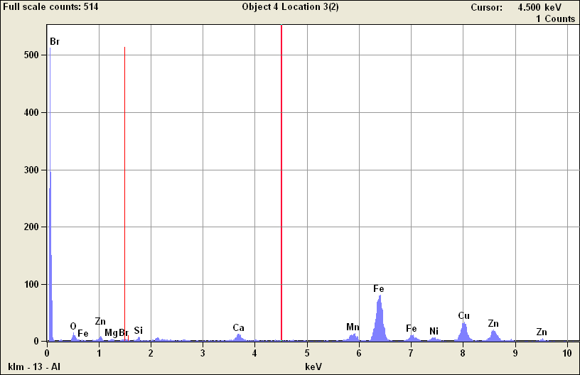

Quantitative Results for: Object 4 Location 3(2)
Element  Line | K-Ratio | Weight % | Weight %  Error | Atom % | Atom %  Error | Formula | Norm.  Compnd%
O K | 0.03 | 7.16 | +/- 0.72 | 21.73 | +/- 2.19 | O | 7.16
Mg K | 0.00 | 0.93 | +/- 0.26 | 1.86 | +/- 0.51 | Mg | 0.93
Si K | 0.01 | 1.05 | +/- 0.16 | 1.82 | +/- 0.28 | Si | 1.05
Ca K | 0.03 | 2.51 | +/- 0.24 | 3.03 | +/- 0.29 | Ca | 2.51
Ca L | --- | --- | --- | --- | --- |  | ---
Mn K | 0.06 | 5.17 | +/- 0.58 | 4.56 | +/- 0.52 | Mn | 5.16
Mn L | --- | --- | --- | --- | --- |  | ---
Fe K | 0.40 | 35.41 | +/- 1.23 | 30.77 | +/- 1.07 | Fe | 35.41
Fe L | --- | --- | --- | --- | --- |  | ---
Ni K | 0.03 | 3.18 | +/- 0.64 | 2.63 | +/- 0.53 | Ni | 3.18
Ni L | --- | --- | --- | --- | --- |  | ---
Cu K | 0.23 | 23.31 | +/- 1.46 | 17.80 | +/- 1.12 | Cu | 23.31
Cu L | --- | --- | --- | --- | --- |  | ---
Zn K | 0.21 | 21.29 | +/- 2.47 | 15.80 | +/- 1.83 | Zn | 21.29
Zn L | --- | --- | --- | --- | --- |  | ---
Br K | --- | 0.00 | --- | 0.00 | +/- 0.00 | Br | ---
Br L | --- | --- | --- | --- | --- |  | ---
Br M | --- | --- | --- | --- | --- |  | ---
Total |  | 100.00 |  | 100.00 |  |  | 100.00

